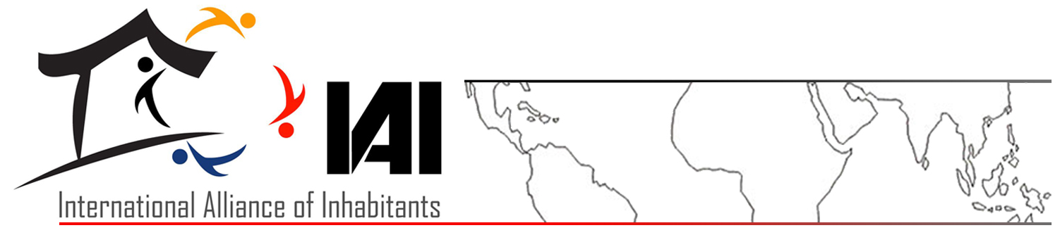

THE INHABITANTS TOWARD THE PEOPLE'S SUMMIT. PROPOSALS AND STRUGGLES FOR LIVING WELL ON OUR PLANET

The International Alliance of Inhabitants, global network of urban social organizations and movements without boundaries, strongly supports the Call of the People's Summit for Social and environmental Justice and the Permanent Assembly of the Peoples, against the commoditisation of life and nature and in defense of common goods, which will take place in Rio de Janeiro, Brazil, 18-23 June 2012, simultaneously to the UN Conference for Sustainable Development (Rio+20).
The crisis of the neoliberal system based on a violator Social Pact
Currently in the world, there is a civilian crisis caused by capitalist colonialism which exploited and plundered nature and humanity leaving it on the verge of extinction. The climate and energy crisis is in a phase of expansion and the imperial economies have applied for themselves structural adjustment policies and often based on bubbles and shocks, including disasters and the supposed “green economy”.
One of the most evident aspects is the increase in insecurity of housing for the population, the homeless and evicted in at risk areas and/or environmental protection, as well as an exponential rise in the land grabbing, a new instrument of colonialism, which amplifies the negative phenomenon’s of globalization, specifically targeting some areas of the planet in terms of dominant economies (industrial agriculture, bio combustibles, tourism), destroying the richness of diversity (communities, environment, local economies) and increasing the inequality with the poorest countries.
The ultimate causes of these violations of housing rights are to be found in the neoliberal system, based on a Social Pact which violates the sovereignty of human and environmental rights, territorial sovereignty, social equality and sustainability.
The struggles of the inhabitants shows the possibility of finding appropriate and revolutionary solutions
Nevertheless, it is not only the different struggles by inhabitant organizations which show the possibility of finding appropriate and sustainable solutions to the urban crisis, of housing and global to recover the sovereignty of human and environmental rights, territorial sovereignty, equality and sustainability, but there also exists the feeling that there is the possibility for revolutionary changes in the 21st Century to which inhabitants could efficiently contribute.
Fundamental to these beliefs and the success of the World Assembly of Inhabitants (WSF Dakar 2011), we have strengthened the principles that guide our actions, in particular the belief that air, water and land are rights and common goods for everyone, they are not goods and that inhabitants have the responsibility to exercise all the human and environmental rights individual and collectively, living, fighting and governing.
Achieving objectives building the Urban and Communitarian Way
In order to achieve these objectives for the International Alliance of Inhabitants it is central to create an “Urban and Communitarian Way”, understanding this as a common space and journey, global and solidarity, of the organizations and the network of inhabitants who share their experiences, make strategies and platforms, administer tools, decide on commitments and put them into practice, in order to reinforce solidarity with the g-local struggles.
Thus we can contribute to the recovery of the social function of property, cities, and territory in general, accrediting that the social movements have a cumulative experience in order to contribute to recovering and defending cities and nature, cultures, knowledge and skills, sustainability, self-determination and the peoples's sovereignty, justice, peace and democracy.
Thus, we are looking to recast the Social Urban Pact on the predominance of the alternative paradigm? of human and environmental rights, as well as on the responsibilities of inhabitants to be the constructors and governors of human settlements, unavoidable pillars for “living well on our planet”.
Dialog and alliances: from Rio to Naples and the next WAI
For these reasons we consider Rio a milestone for strengthening the di dialog and alliances, for defining a platform and a program for the common strugglesfor inhabitant, rural, workers, women and environmental organizations and all those who fight for the integral management of the earth, rebalancing rural-urban relations, Right to the City and Right to the Land.
A dialog for spreading on all levels and continuing in spaces such as the World Urban Forum – Urban Social Forum (Naples, September 2012) and the World Assembly of inhabitants – World Social Forum (2013), and thus contributing to “living well on our planet”.

